Creating your Word Bibliography (MAC) 2011 v14.1.0
- Open a NEW document in ‘Word’
- Select ‘Document Elements’ from the top tool bar
- Select ‘Harvard’ from the drop down selection under ‘References’
- Click on ‘Manage’ under the Harvard drop down bar
- The little box below will display to the right of the Word page. Click on the + symbol at the bottom left of the little box
- A larger box will display (shown below to the left)
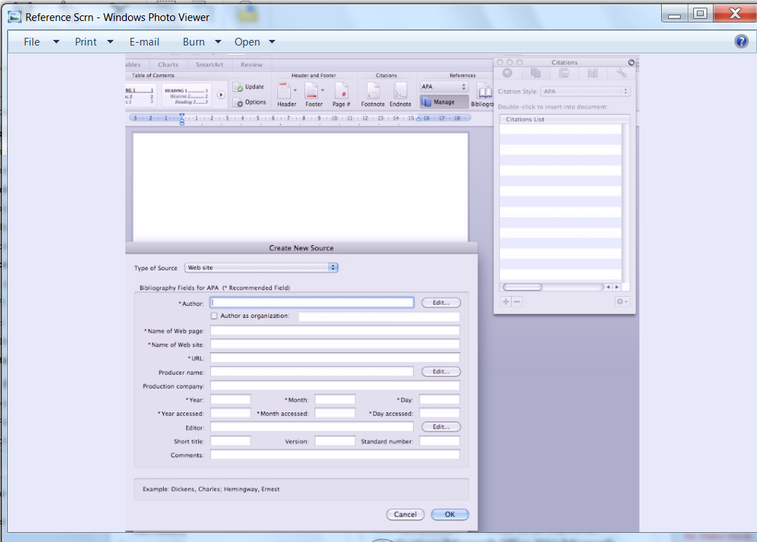
- Select the ‘Type of source’ from the drop down selection ie. Book, internet etc.
- Complete each section with the information taken directly from the resource. If the information is not available ie. No author, then leave it blank.
NB: When you click in each box, an example of how to enter data displays on the bottom of the box.
- Once you have completed the citation it appears as shown:
(Grant, 2013) in the little box
- This is simply a citation to be used if quoting a person within your text.
- To create your Bibliography select:
‘Bibliography’ and then in the drop down choose ‘Bibliography’ again

Grant, A., 2013. Saying NO to plagiarism. Erina: GRIF Publishing.

